The Setup

1. Download the latest MinGW installer.

<http://sourceforge.net/projects/mingw/files/>

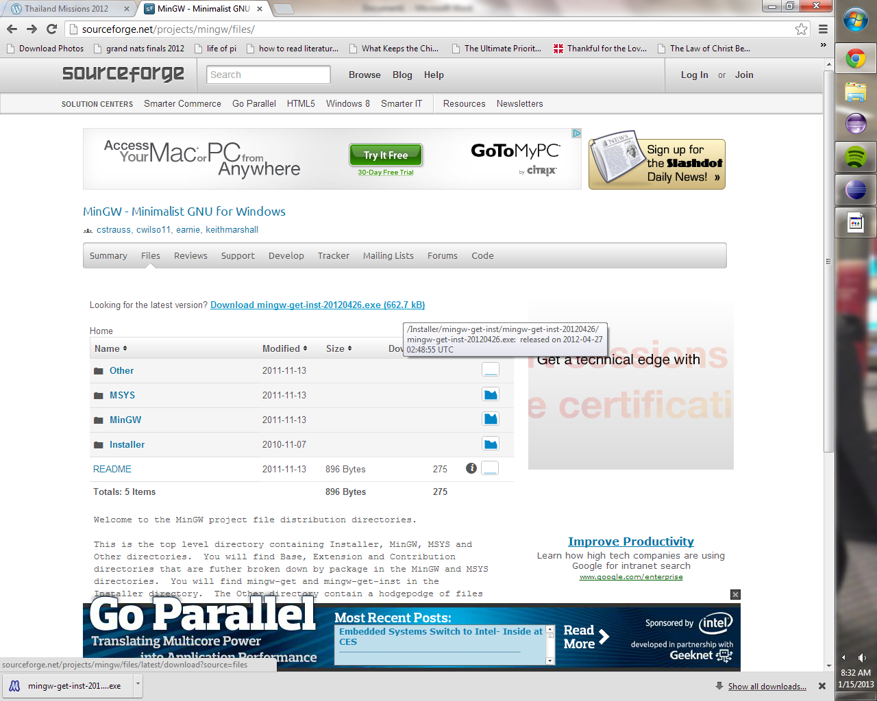

2. Run the installer.

3. Check: “Use pre-packaged repository catalogues” (either option will work, but using the prepackaged repositories should make installation faster).

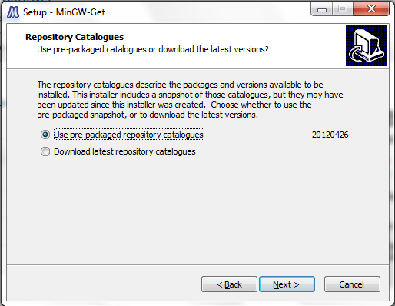

4. Install in C:\MinGW (recommended because that’s what this tutorial will assume).

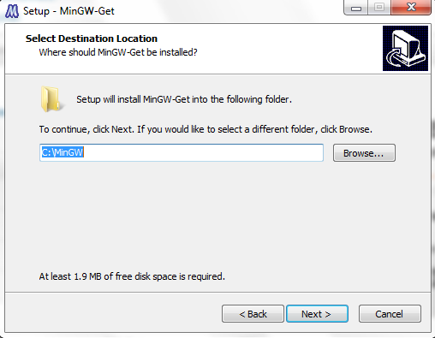

*Creating a Start Menu folder in the next window is optional. I don’t like them so I don’t create them haha.

5. Select the “C Compiler” and “C++ Compiler” and whatever other compilers tickle your fancy. For Eclipse C++, the C and C++ Compilers are the only ones necessary.

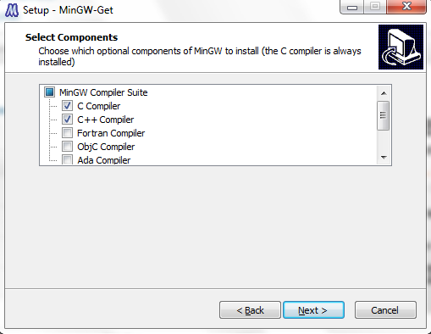

**6. IMPORTANT: Select the MSYS Basic System. Eclipse will not compile C++ programs without this.**

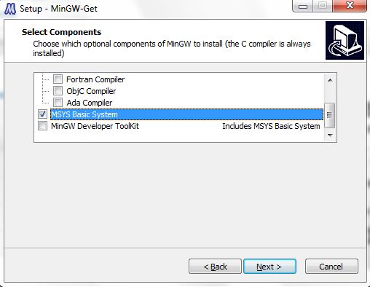

7. Verify that your final screen looks something like this:

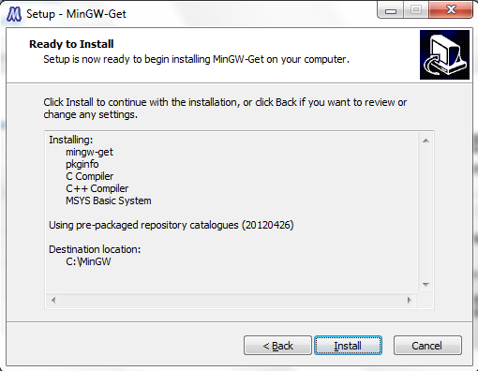

8. After waiting forever for installation to complete, right click “Computer” and go to properties (Windows+Pause also works for you shortcut junkies). Your screen should now look like this:

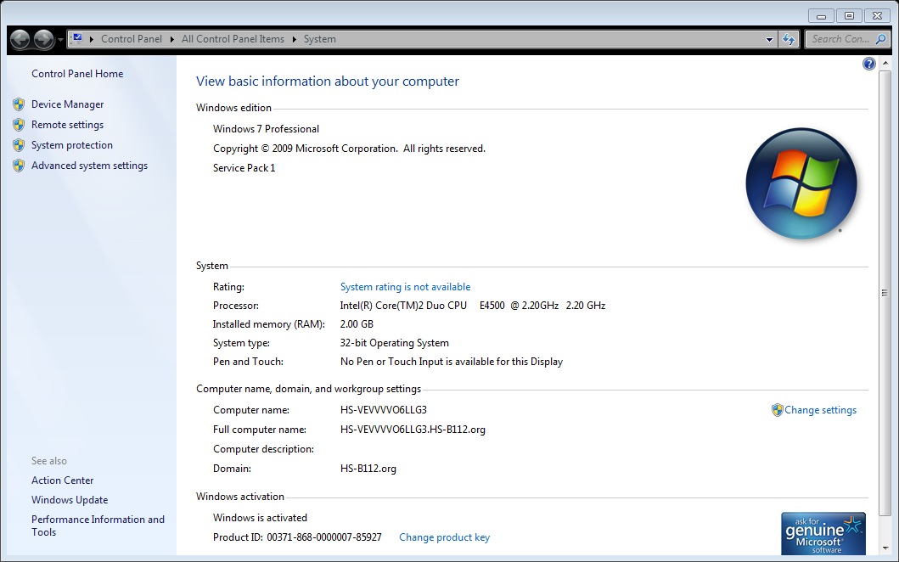

9. Click the “Advanced system settings” in the left banner. Make sure you are a local system administrator at this point. A window should pop up that looks like this:

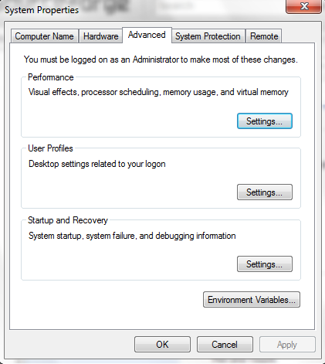

10. Click the “Environment Variables…” button. A window will pop up that will look like this:

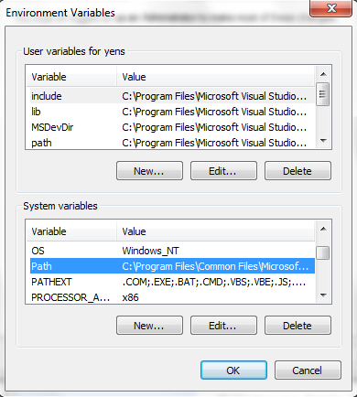

11. Scroll down to “Path” under “System variables.” Click the “Edit…” button and a dialog box will pop up that looks like this:

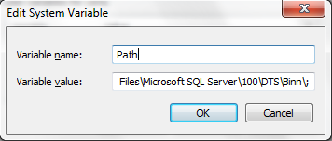

**IMPORTANT: Do not modify or delete any of the other paths in this variable. It may/will wreak havoc on your computer. If you accidently do something you didn’t mean to, just click “Cancel.”**

12. Append “C:\MinGW\bin” and “C:\MinGW\msys\1.0\bin” to the “Variable value:” text box separated by a semi-colon. What you entered should look like this: “C:\MinGW\bin;C:\MinGW\msys\1.0\bin”. The dialogue box should now look like this after the newly inputted paths:

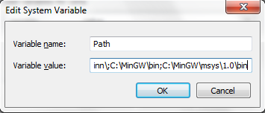

*This is assuming you installed MinGW into the default “C:\MinGW” directory.

13. Click “OK” on the three popup windows open. Go ahead and close the Computer properties window.

You’re now finished with the setup! Continue for the steps that must be completed every time before creating a new C++ project in Eclipse.

Two versions will be discussed here, Eclipse Indigo and Eclipse Juno.

Creating a new C++ project (Eclipse Indigo)

1. A window will popup that looks like this when creating a new C++ project:

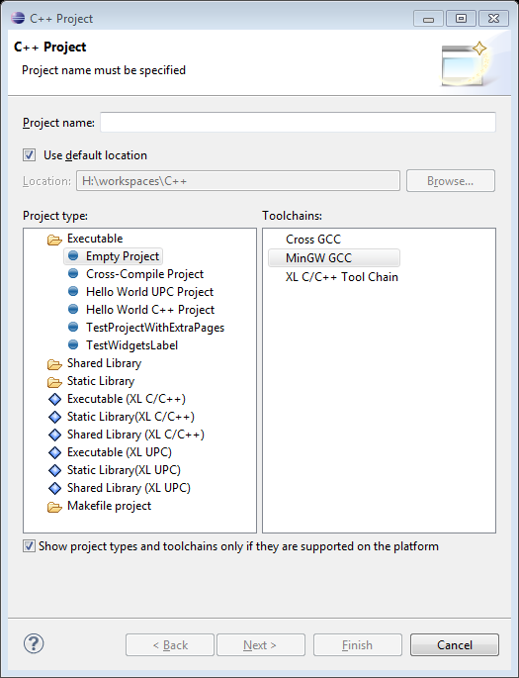

Make sure that “MinGW GCC” is selected in the “Toolchains:” box. Name your project and click “Finish.” Your project will now compile and run properly assuming no errors by you, the programmer.

**IMPORTANT: MinGW does not like spaces, so no spaces in your project title.**

Creating a new C++ project (Eclipse Juno)

1. A window will popup that looks like this when creating a new C++ project:

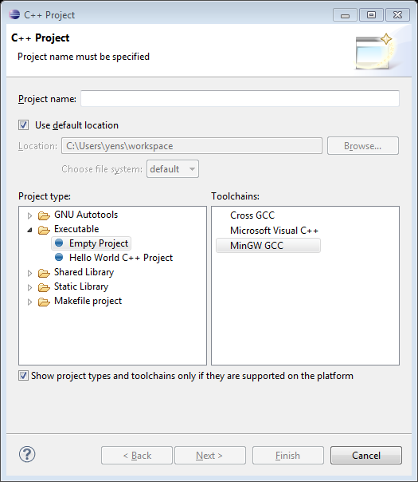

Make sure that “MinGW GCC” is selected in the “Toolchains:” box. Name your project and click “Finish.” Your project will now compile and run properly assuming no errors by you, the programmer.

**IMPORTANT: MinGW does not like spaces, so no spaces in your project title.**

Hope this guide helped you get Eclipse and MinGW working with C++! Good luck and happy hunting.